USER MANUAL

**E-Commerce**

1. When the user first enters the e-commerce site the will be met by this screen

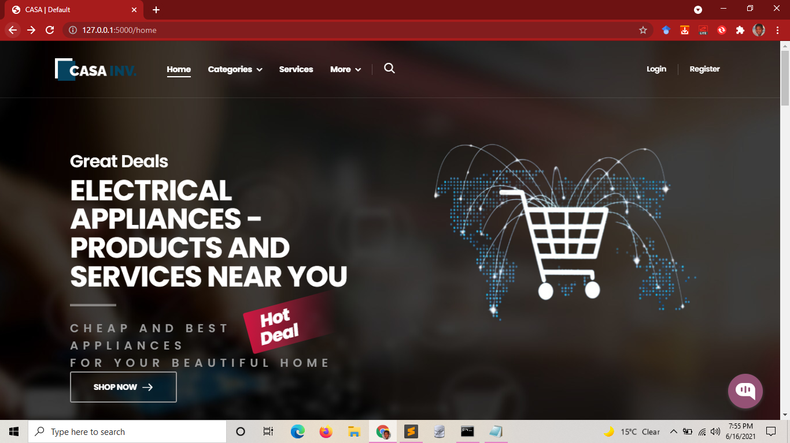

2. To purchase products/ request service they will first need to login/register.

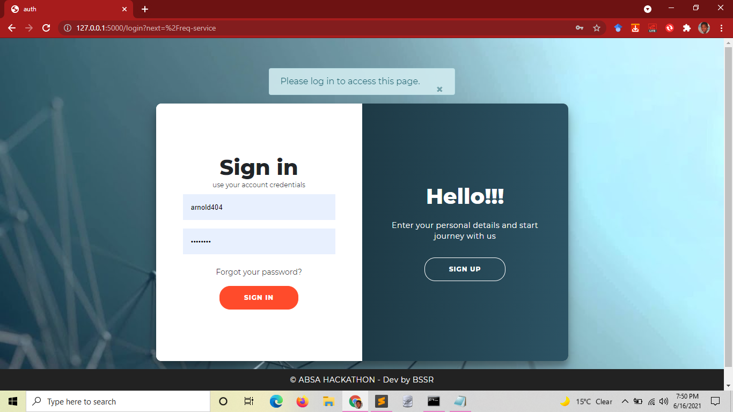

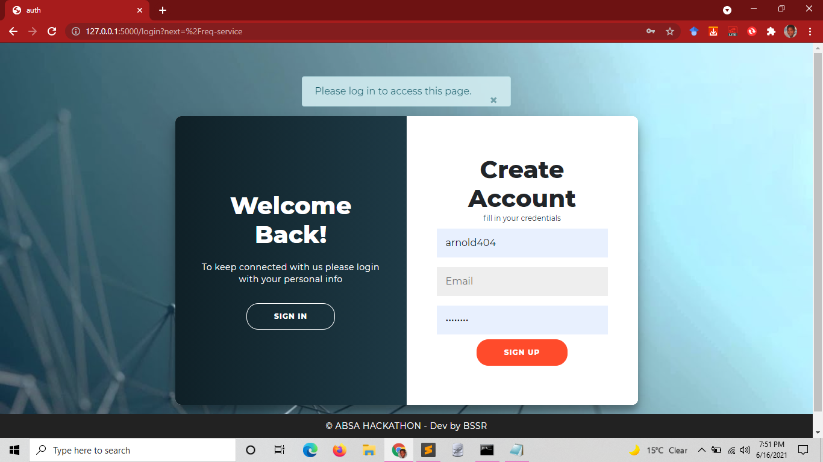

**Purchase Product**

3.By clicking categories users can view all the listed products by categories

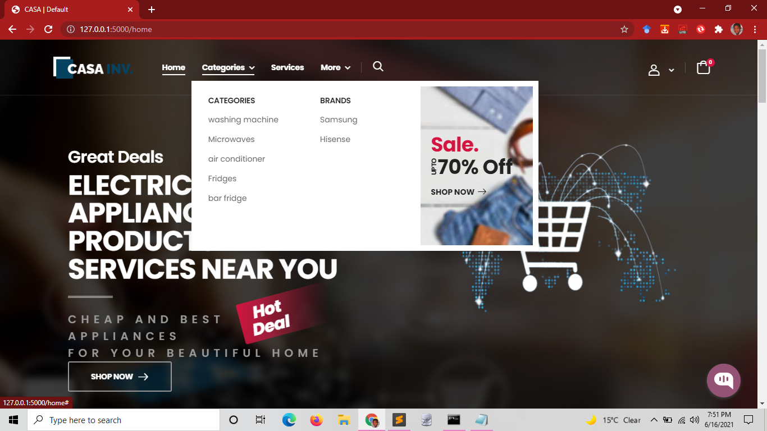

4. By clicking add to cart the product will be add to the cart

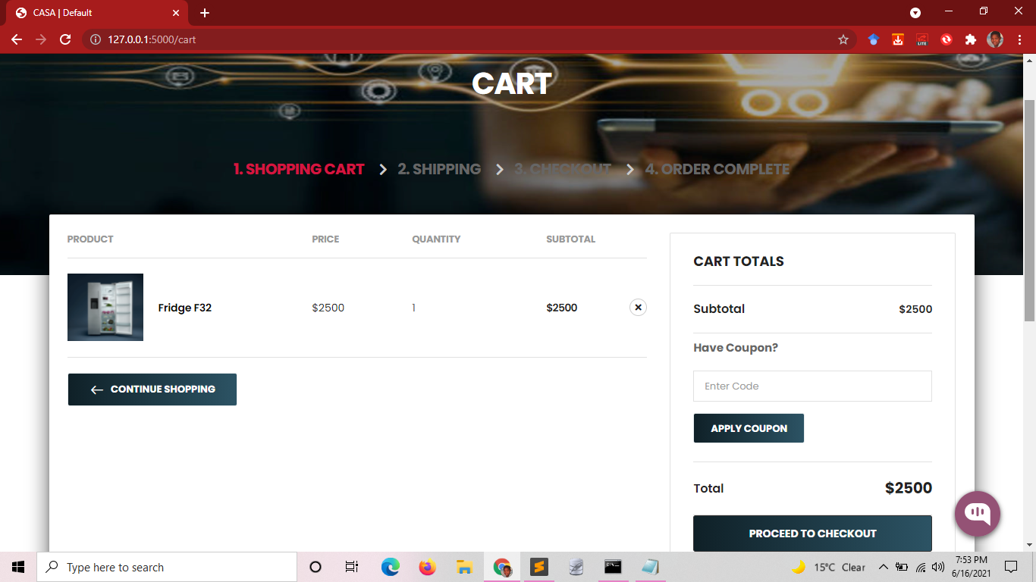

5. By clicking “Proceed to check-out” user will then be prompted to add “Billing details” if it is their first purchase

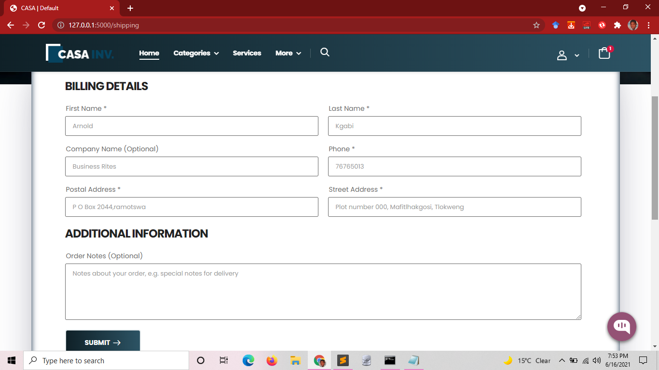

6. Upon clicking “Submit” a prompt to enter bank details will appear and these details need to be added to complete the purchase.

7. When the purchase is complete the user will be directed to a “thank you page”

**Request Service**

By clicking “Services” the user will be redirected to the Services dashboard this is where all the services that have been requested will appear

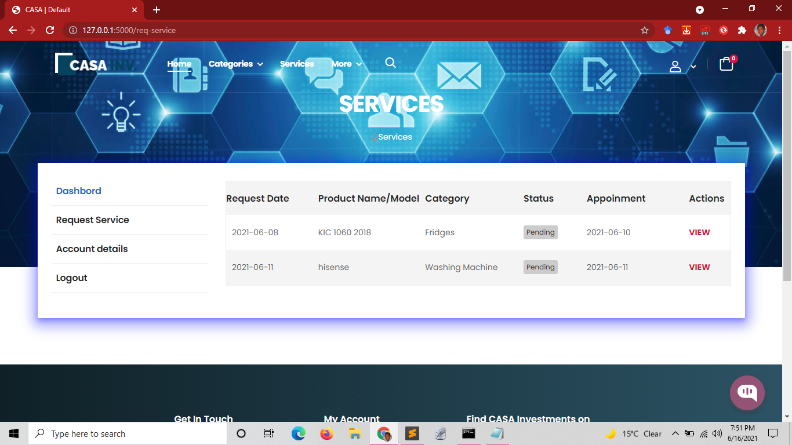

To request for a new service the user will have to click “Request Service” the user will then have to fill in the form and submit it in order for the SMEs to receive the request.

To view more about the request the user will have to click “View” under “Actions”

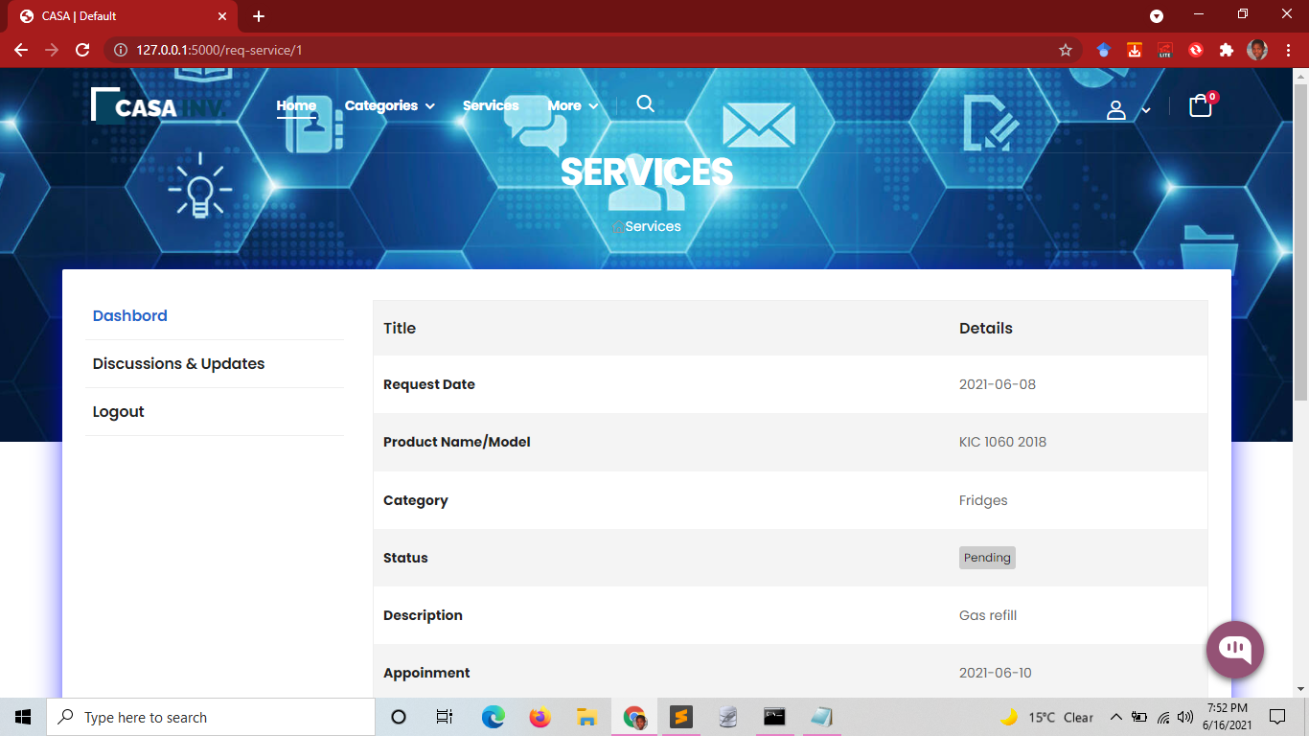

Here the user will need to click “Discussions & Updates” to communicate with the SMEs



**Organizational Portal**

To access the system the SMEs need to have an account that has been registered by the Admin

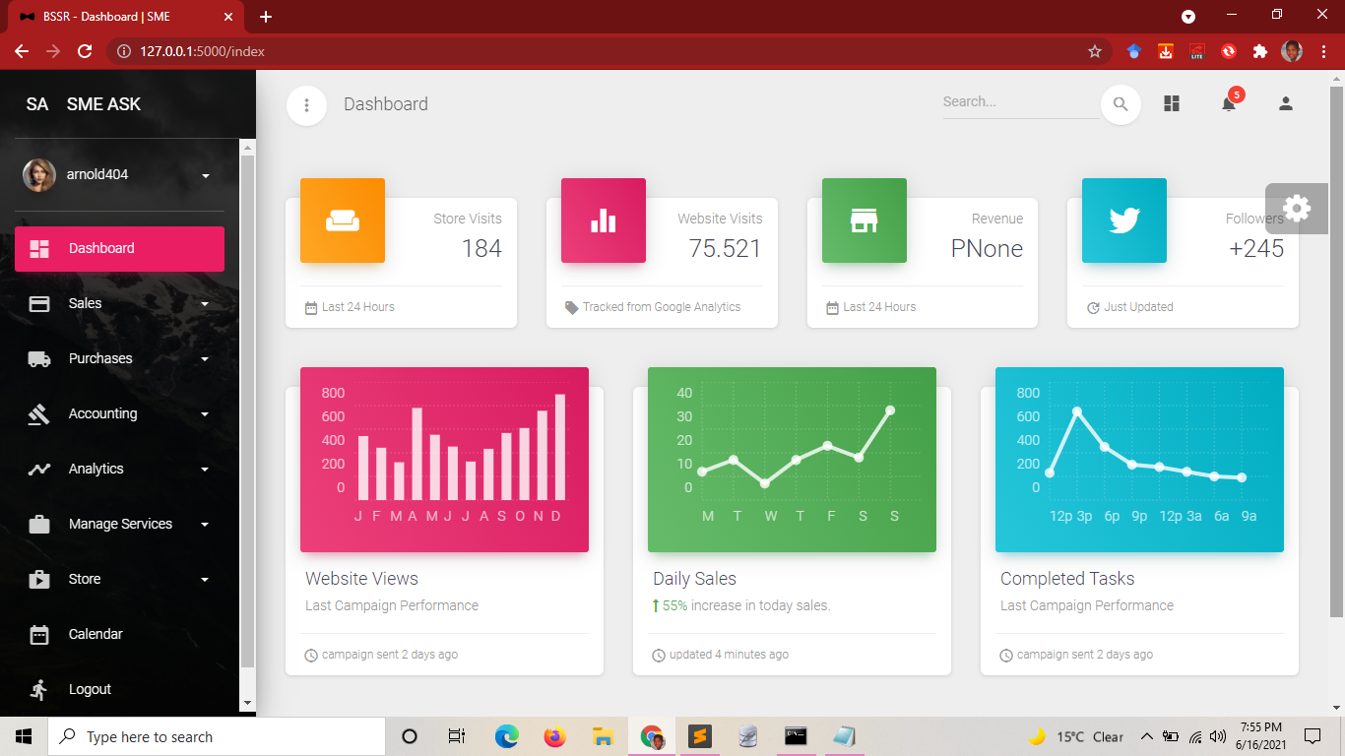

Here the user can add sales and purchase by clicking “Sales” the “Add Sales” (Same applies to Purchases)

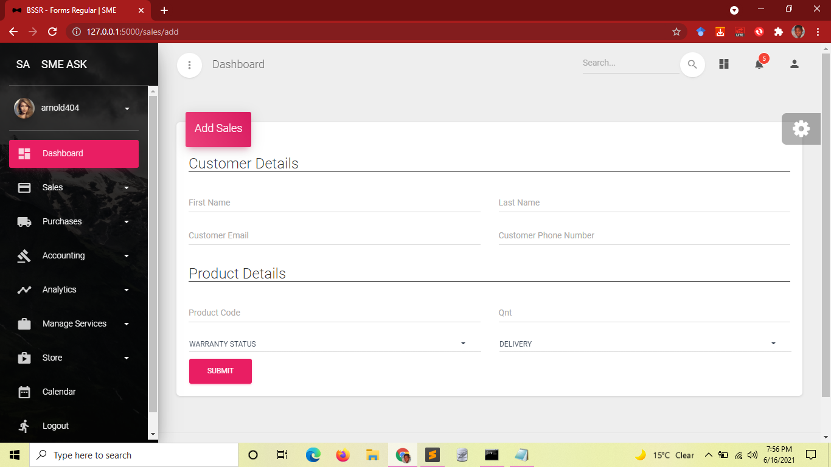

They can also view all the previous sales recorded

The SMEs can also manage the store by adding products to the e-commerce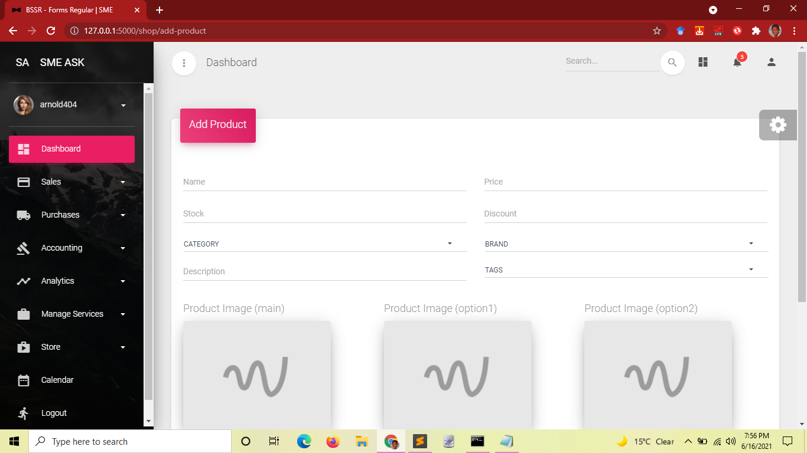

Chatbot

Users and the SMEs can also communicate using the chatbot